ESTIMATING THE AMOUNT OF Base MONEY that is necessary

In this note we sketch how to estimate the amount of base money that is necessary in a monetary system with GDP-linking. Thereafter we show how this estimate can be used to develop a rule based monetary policy. But first we give an illustration of the use of the money.

1 The use of the base money, an illustration

Money is a medium of exchange. It is the lubricant of the real economy. There are five “places” where the money has to fulfill this role (Figure 1):
- in households for housekeeping,
- it is the liquid part in working capital for corporations
- or in working capital for government,
- it is used in the investment world, e.g. to create flexibility in the investment portfolios; one could call this the working capital in the investment world
- and in the last place, it is used for the formation of capital.
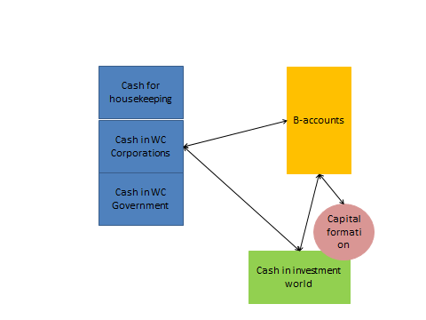
Figure 1: Distribution of the base money

In working capital (households, corporations and government) the money is used to buffer temporary discrepancies between the flow of income and the flow of expenditures that are the result of the business. In the investment world it is used to be able to change the composition of the portfolio by selling certain assets and buying other assets. Here the transactions are more independent of each other than in case of working capital.

The last function of money (capital formation) is also performed by households, corporations or government, but is distinguished from the working capital function, because it is accompanied in general by significant discontinuities in the need for money. Large capital investments for production and innovation demand extra liquidity. It is important to check whether the monetary system facilitates this need adequately. Insofar as these capital investments are directly financed, they belong to the investment world and the money required is included in the money required there anyway. But another part of these investments has to be financed or pre-financed through the B-accounts. The money that is not needed as working capital or in the investment world as exchange money, is available for the B-accounts of the banks. From these B-accounts it can be borrowed back into working capital or investment world and it can also be used for capital formation (not all arrows are drawn in the figure).

We developed an Excel model to illustrate the movement of the money. That model is explained first.

With respect to working capital, base money (on current accounts) is assumed to be the only form of liquidity. Alternatives are more expensive or impossible. One may expect that the quantities of money for working capital fluctuate around some average. In the Excel model we assume that there is a norm quantity ($norm$) for each of the three types of working capital and that the actual quantity, $x(t)$ (all variables are expressed in a fraction of the GDP) behaves in the following way:

$$x\left(t+1\right)=x\left(t\right)+\left(norm-x\left(t\right)\right)∙a+noise$$

Time in the Excel model is discretized to months. The noise is uniformly distributed on $[-range∙x\left(t\right),+range∙x\left(t\right)]$. As $range$ for the noise we choose $range=r∙({turnover}/{norm})∙x(t)$. If $x(t)$ remains close to its norm, the range is about equal to $r∙turnover$.

This holds for all three variables, households, corporations and government. But in case of the corporations the norm depends on the growth. The more growth, the more working capital is needed. The norm is increased with $b∙growth$. The growth is the growth of the economy per year. If the average throughput time of the production is 0.2 (year), an increase of the working capital norm of $0.2∙growht$ may be expected (expressed as a fraction of the GDP). So,$b= 0.2$ is reasonable then.

Although the transactions in the investment world are often settled in another way (shares and bonds and other assets for shares and bonds and other assets), base money may be useful to switch from one asset to another in a portfolio. Suppose each asset is replaced every two years and it takes a two weeks interim period: the old asset is sold first and the new one is bought two weeks later or a loan is acquired to buy the new asset two weeks before the old asset is sold. That contributes an average of 2% of the total value of all portfolio’s to the amount of base money that is required. Given that the total private wealth is about equal to 6 times the GDP (compare Piketty) that is 12% of the GDP. In this way it is possible to determine a norm for the base money that is needed to create flexibility in the investment portfolios. In the Excel model this is put for the moment at 12% of the GDP. No stochasticity here. Adding stochasticity here would have the same effect as adding more noise to the working capital elements.

Let $f$ be the total amount of base money (also as fraction of the GDP). It is assumed to be constant. This is realized by adding the tax on the current accounts to one of the current accounts of the government. Let $x_{H},x_{C},x_{G},x_{I}$ be the base money for housekeeping, for working capital for corporations and governments and for the investment world and $s=x_{H}+x_{C}+x_{G}+x_{I}$. The difference $f-s$ is put made available to one of the B-accounts:

$$b\left(t\right)=f-s(t)$$

Note that the amount of base money available on the B-accounts is the difference of what is made available to the banks and what is lend back into the economy.

Then the effect of the participation of banks (B-accounts) in capital formation. Let $p$ be the average of the total size of the capital formation opportunities (per year, so per month it is $p/12$). The size per month is stochastic, uniformly distributed on $\left[0,p/6\right]$. We assume that all these opportunities have to be financed or pre-financed through the B-accounts. This may restrict the flow of opportunities that can be grasped ($q(t))$. The sooner the base money that is involved comes back in normal working capital or at the B-accounts, the less the pressure is on the B-accounts. We assume that the money that is bonded by a capital formation event fades away exponentially. So, the total amount of base money for capital formation ($Q$) develops in the following way:

$$Q\left(t+1\right)=γ∙Q\left(t\right)+q(t+1)$$

, with $1/{(1-q)}$ the average number of months before the money involved returns to B-accounts or working capital. The economic growth is assumed to depend in the following way on $r$:

$$gr\left(t+1\right)=\left(1-α_{G}\right)∙gr\left(t\right)+∙c{∙α}_{G}∙(q\left(t\right)-norm/12))$$

The norm is the capital formation that is necessary to realize a growth equal to 0. In the Excel model we have chosen $norm=0.2$ (per year, so per month it is $norm/12$). For $q\left(t\right)=0,$the growth (per month) is going to be equal to $-c∙norm/12$. The quantity 0.2 is inspired by the situation in the Eurozone.

The simulation is meant to illustrate, not to generate serious estimates of the monetary policy parameters that are necessary. It may nevertheless be useful to try something. As turnover for households, corporations and government we choose 1, 2 and 0.5. As working capital norm for households, corporations and government we choose 0.2, 0.1 and 0.05 and as norm for exchange money in the investment world we choose 0.12. A total amount of money equal to 0.8 is reasonable then. The average amount of money made available by the economic actors through the B-accounts is equal to 0.33 then. The range and the tendency to the norm ($a$) determine the variability in the system. If the tendency is chosen such that the aim is to correct a deviation in (about) a year, $a=0.1$ is reasonable. A sample result for the missed capital formation opportunities and growth is given in the figure below. The parameter for the flow of capital formation opportunities is $p=0.4$ and the parameters for the growth behavior are $c=0.1$ and $α_{G}=0.05$. Relatively few capital formation opportunities are missed in this case (about 15%).
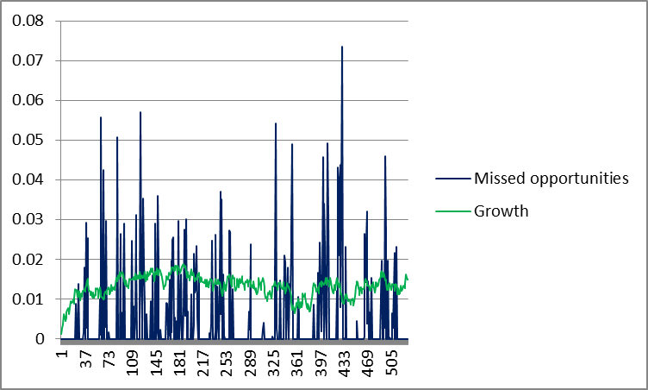

Figure 1: Sample result

2 Estimating the amount of money that is necessary

The estimation procedure is sketched along the lines that are used in Section 1 to describe the use of the money.

The first step is to determine an estimate of the amount of money needed for working capital in households, corporations and government. Here it is assumed that base money is the only form of liquidity. Alternatives are more expensive or impossible. One may expect that the quantities of money for the different forms of working capital fluctuate around some average. This average is the result of the norms with respect to working capital of each of the individual players. The sharper the average player controls on this norm, the smaller the fluctuations around this average are. See the model in Section 1. In case of corporations one may expect a positive dependence of the average on the growth of the economy, because of the time delay between the procurement of the raw material and the sales of the final products. By empirical research it is possible to derive estimates for the average and the range of the base money that is necessary in working capital. These estimates can be used to calibrate a model, like the model in Section 1.

The second step is to determine an estimate for the amount of base money necessary in the investment world. Here we suggest the procedure that has been sketched already in Section 1. So, estimate the frequency at which money is used to replace an asset for another one. And estimate also the time this takes. An adequate sample of investment portfolios is necessary here. Together with the total size of all portfolios this leads to an estimate of the total amount of money necessary In the investment world.

The third step is to estimate the amount of money that is necessary for capital formation. Capital formation requires extra money during a certain time. It has to be taken into account that as soon as the money fits again in the working capital (a, b, and c) or in the exchange money in the investment world (d) the money is counted there already. In Section 1 we assumed that the complete capital formation bonds extra money during a certain (average) time. That leads to two elements in the estimation procedure, the average time and to size of the capital formation that is necessary. The first element is most complicated. One has to choose a suitable sample of capital formation events and follow the money bump that accompanies the events. The second element is a matter of looking back to various years and check what the capital formation in a good year was as fraction of the GDP.

Finally, the influence of fluctuations/stochasticity has to be estimated. A model like in Section 1 may be useful here.

3 A monetary policy based on simple rules

The aim is to develop simple monetary rules. First the choice of the money tax, $τ$. In case of a too high $τ$ the available base money becomes ineffective. The economic actors search for other possibilities to settle their transactions and the base money ends for a large part at the B-accounts of the banks and remains there. The other extreme is a too low $τ$. For instance $τ=0$. In this case, the GDP-linkage implies that just storing base money leads to a result that keeps up with the GDP. Storing base money becomes an attractive “investment”. The base money is meant to be a means of exchange. So, it is important to choose $τ$ sufficiently high to prevent that base money is used by investors as a structural investment possibility. It is sufficient to choose $τ$ equal to or a little higher than the expected increase in the real GDP ($\hat{π}$). Recall that 0.02 is the inflation goal of the ECB. With $τ=\hat{π}+0.02$ the buying power development satisfies that goal. Therefore we choose $τ=\hat{π}+0.02$ and we assume this prevents that having base money becomes a goal instead of a means.

Next the total amount of base money as fraction of the GDP ($f$). The approach suggested in the previous section can be used to determine an estimate of the amount of money that is sufficient for all demand (working capital, exchange money and capital formation). The possibility to borrow from the CB can be used as a kind of safety valve. It is not necessary to bother about too much money. In a GDP-linked system, the buying power development is very stable. It is independent of price developments and decreases at rate $τ-π$. Of course there are moderate fluctuations in the expected buying power development, leading to some fluctuations in the aggregate demand. And if the amount of base money is large, these fluctuations may lead to some changes in the (nominal) prices, so some inflation. But not so sharp that the effects cannot be neutralized by the GDP-linking.

It matters of course whether and how the possibility for the banks to borrow base money from the CB (C-accounts) is exploited. Most straight forward is not to use it. Or only to cover unexpected shortages at the B-accounts. It is important then that the cost of borrowing is significantly higher than the cost for borrowing from other economic actors. The real revenue on idle base money is equal to $π–τ$. That means that in case of plenty of base money, the banks are able to get base money for little more than $\hat{π}–τ=-0.02$. That means that the interest on base money borrowed from the CB can be kept low, e.g. 0.005.

Monitoring the system is important. And especially during the start-up it is necessary to combine the estimates with trial and error. Start with an amount of money that is certainly too high. Then reduce the amount and check when banks start to borrow from the CB. The system is vulnerable for investments in base money by financial corporations. A tax about equal to $\hat{π}+0.02$ is presumed to prevent this. But it is useful to check it. The labeling that is necessary for the tracking of the GDP-proxy can also be used to monitor the (aggregate) possession of base money by financial corporations. If this shows investment in base money, the tax has to be increased.

Thomas Piketty, “Capital in the Twenty-First Century”, Harvard University Press

